CSA1509-Cloud computing and big data analytics
Experiment-4
Create a simple cloud software application for Book Hub book reservation system for
ABC library using any Cloud Service Provider to demonstrate SaaS include the
necessary fields such as Title of the book, author, publications, Year, edition, no of
copies, Rack no, status (taken/returned) etc.
Input
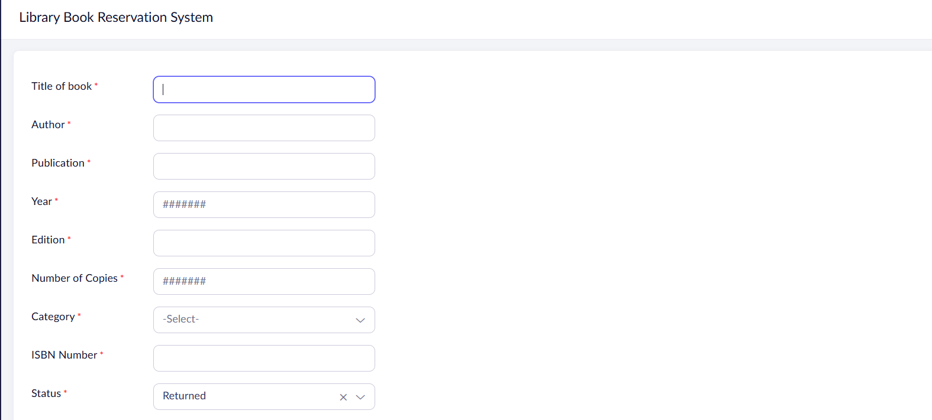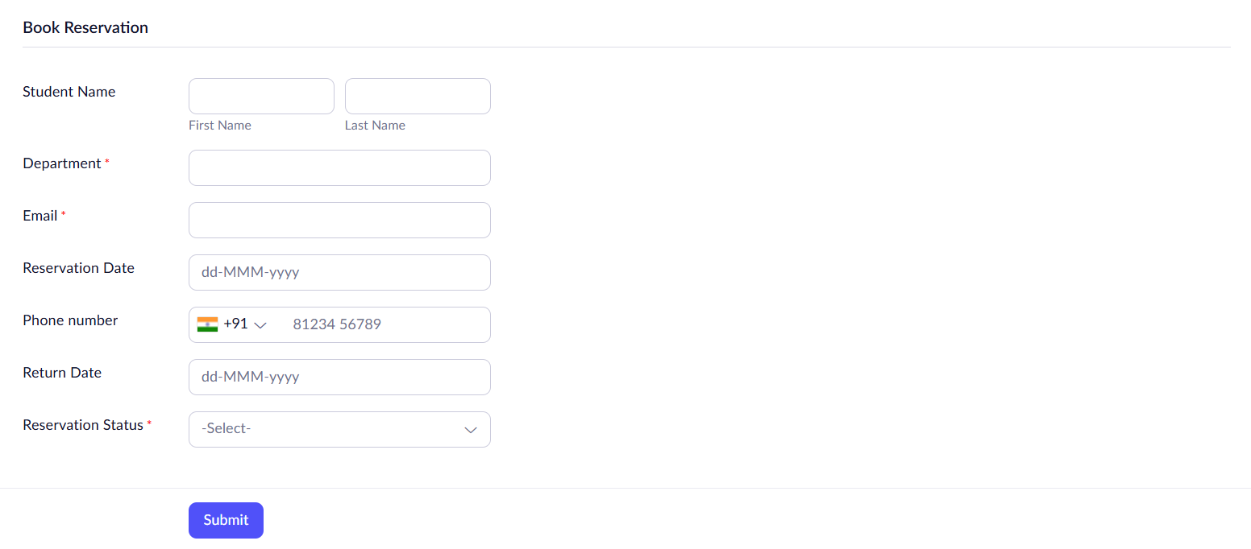
Output
